Project Design Phase-II
Technology Stack (Architecture & Stack)
Project Name | AI StudyBuddy
Team ID | SWTID-2026-6718
Date | 27 September 2026
Maximum Marks | 4 Marks

Technical Architecture
AI StudyBuddy is a backend REST API built with Node.js and Express.js. Client requests (from the bundled HTML/CSS/JS frontend or a tool like Postman) pass through authentication and role-authorization middleware before reaching the appropriate controller. The application uses MongoDB (via Mongoose) as its database and Google Gemini 2.5 Flash as the external AI service for summarization, flashcards, quiz and study-plan generation.
Table 1: Components & Technologies
S.No | Component | Description | Technology
1 | User Interface | How the user interacts with the application | HTML5, CSS3, Vanilla JavaScript
2 | Application Logic-1 | Handles REST API routing, request processing and application flow | Node.js, Express.js
3 | Application Logic-2 | Handles authentication and authorization | JWT (jsonwebtoken), bcryptjs, Express middleware
4 | Application Logic-3 | Handles file upload and AI processing | Multer, Google Generative AI SDK (Gemini 2.5 Flash)
5 | Database | Stores users and study materials | MongoDB, Mongoose
6 | File Storage | Temporary storage for uploaded study files | Local uploads/ directory
7 | External API-1 | Generates AI-assisted summaries, flashcards, quizzes and study plans | Google Gemini 2.5 Flash API
8 | Infrastructure (Server / Cloud) | Backend runs on Node.js; AI service is cloud-based | Node.js Server + Google Gemini Cloud

Table 2: Application Characteristics
S.No | Characteristics | Description | Technology
1 | Open-Source Frameworks | Backend development uses open-source runtime, framework and database technologies | Node.js, Express.js, Mongoose
2 | Security Implementations | Protects user accounts and APIs using authentication, password hashing and role-based access control | JWT, bcryptjs, Role-based middleware
3 | Scalable Architecture | Layered structure (routes/controllers/models/utils) allows features to be added independently | MVC-style layering, Express.js
4 | Availability | Backend and AI service accessible whenever Node.js and Gemini API are reachable | Node.js, Google Gemini API
5 | Performance | AI outputs are cached on the Material document to avoid repeat AI calls | Mongoose, MongoDB

Technology Stack Summary

Backend
Node.js + Express.js

Database
MongoDB + Mongoose

Authentication
JWT + bcryptjs

AI
Google Gemini 2.5 Flash API

File Upload
Multer

Development Environment
Visual Studio Code

API Testing
Postman
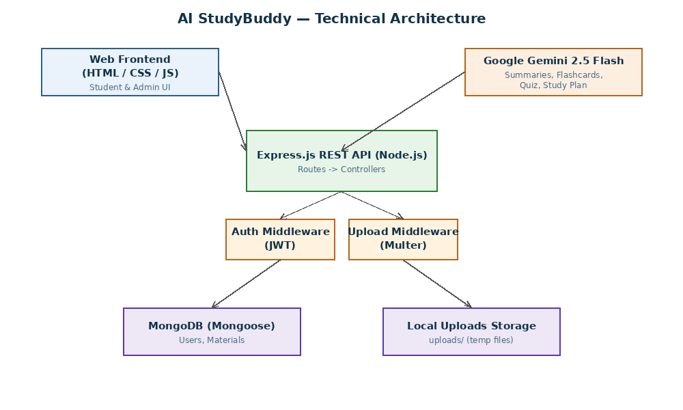
Figure 1: AI StudyBuddy Technical Architecture

